

EE366L/CE366L: Introduction to Robotics Lab

Dr Basit Memon

Muhammad Hassan Shah

Lab 8: Adding Visual Sensing to Our System

Sadaf Shaikh and Mohammad Hasan Tariq

April 20th 2022

Task 8.2

(a)

Resolution of Color Camera = 1920x1080

Resolution of IR camera = 640x480

(b)

The Color camera has a frame rate of 30 fps.

The IR camera has a frame rate of 200 fps.

(c) Depth FOV (degrees) = H: 693 / V: 542

(d) 0.9 mm

The depth start point is the distance between the actual center of the camera and the front of lens that is the point the depth can physically be measured. At this point depth=0. This offset takes form as a result of the limitations imposed in how the camera is manufactured and that the center exists somewhere inside the camera.

To better understand what the depth start point actually means, we placed a cube in the field of view of the camera. Hovering over the cube’s top face in the depth sensor stream, the depth measured by the IR sensor was noted. We, then, physically measured the distance between the top face of the cube and the front of the lens. The difference between the depth coming from the depth sensor and the depth measured physically came out to be around 0.9mm.

Task 8.3

We use the following expression, studied in class, to determine the focal length:

Field of View (FOV) = H = 2 =

The focal length of the height between the base and the sensor is 660 mm.

Task 8.4

**Modified Code**

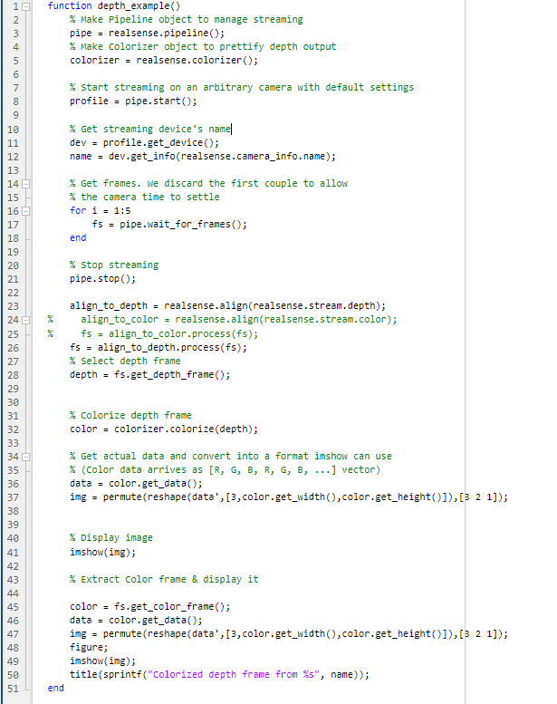

Task 8.5

**Modified Code**

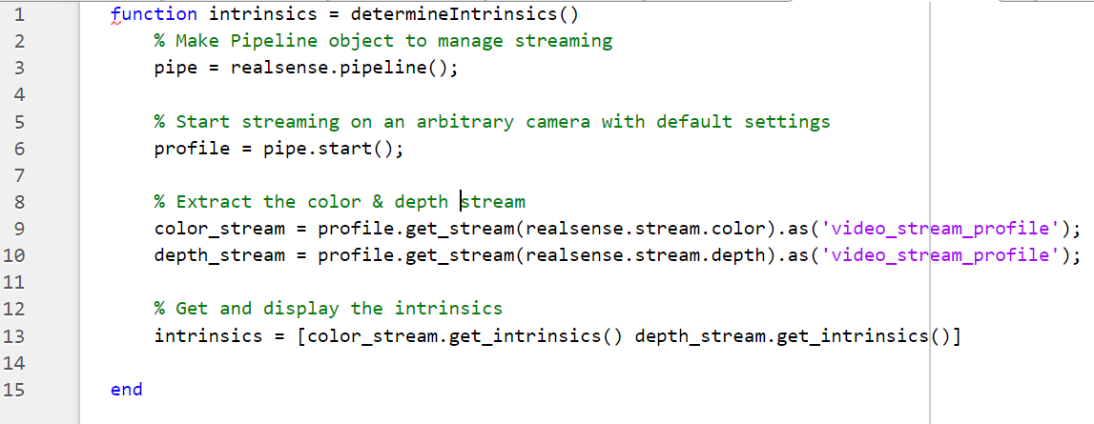

**Intrinsic Parameters**

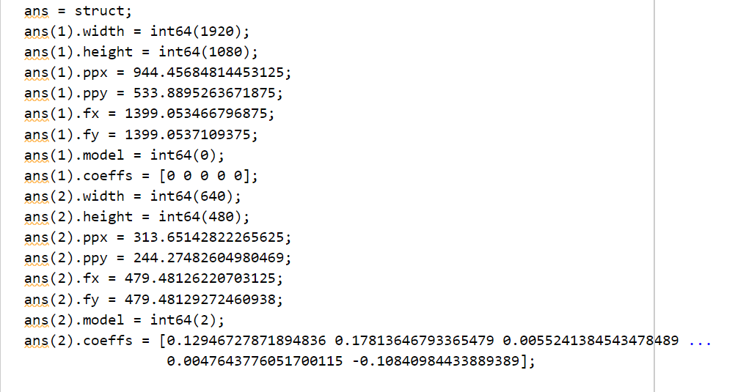

Where, index 1 denotes color sensor intrinsic parameters and index 2 denotes depth sensor intrinsic parameters. The width and height fields describe the number of rows and columns in the image, respectively. The fx and fy fields describe the focal length of the image, as a multiple of pixel width and height and are allowed to be different. The ppx and ppy fields describe the pixel coordinates of the principal point. The model field describes which of several distortion models that we studied in class was used to calibrate the image and the coeffs field provides an array of up to 5 coefficients describing the distortion model.

Task 8.6

**Extrinsic Parameters – Transformation from depth camera to color camera**

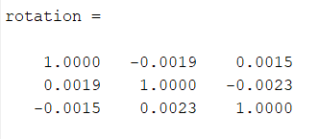

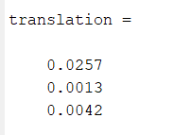

We can align the color image to the depth image by adding the following lines of code to the code from Task 8.4 before selecting depth or color frame:

align_to_depth = realsense.align(realsense.stream.depth);

fs = align_to_depth.process(fs);

**Aligning Color Plane (1920x1080) on Depth (640x480) - Reducing the Color Plane size to fit the Depth plane**

We observe that the depth frame image is a lot smoother.

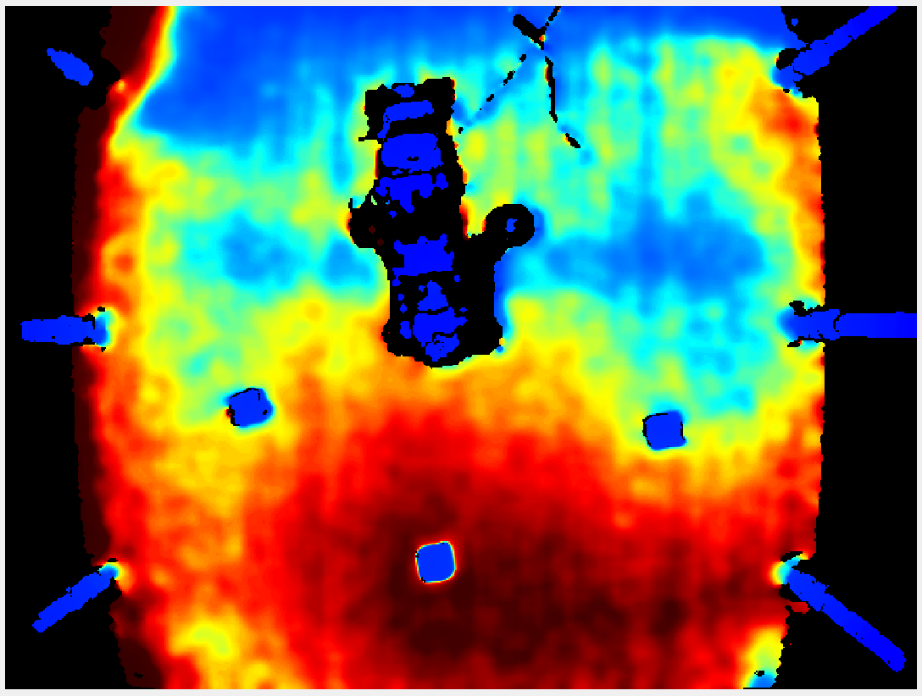

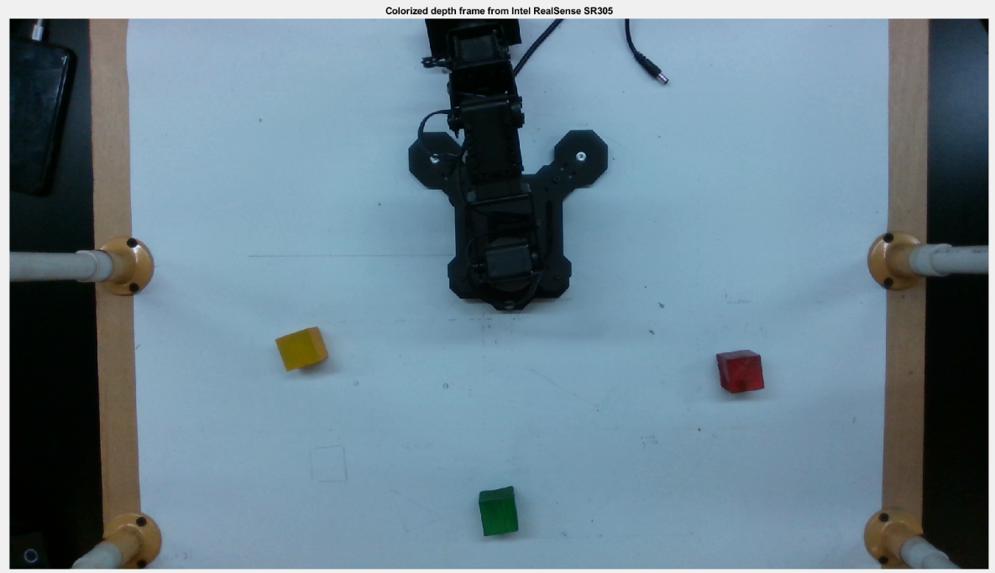

**Aligning Depth (640x480) on Color Plane (1920x1080) – Stretching Depth plane to fit Color frame size**

We observe that the pixels in the depth frame are enlarged and the image is no longer smooth.

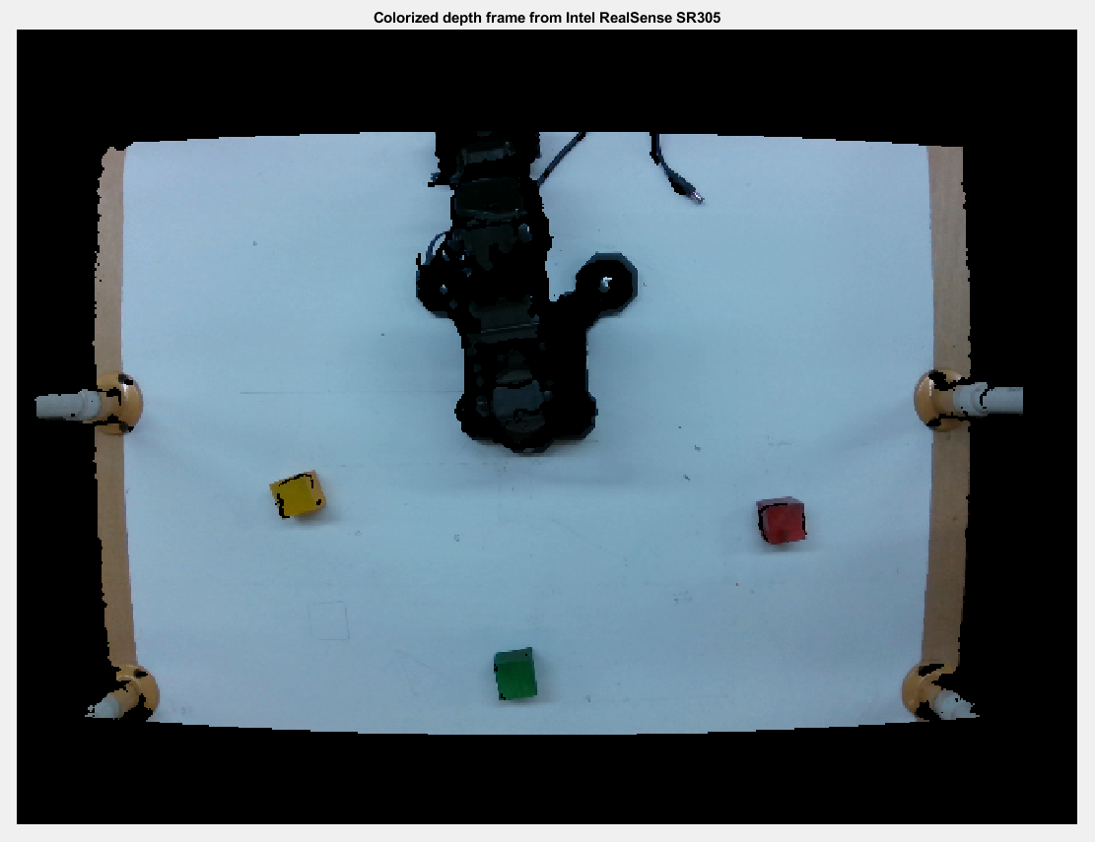

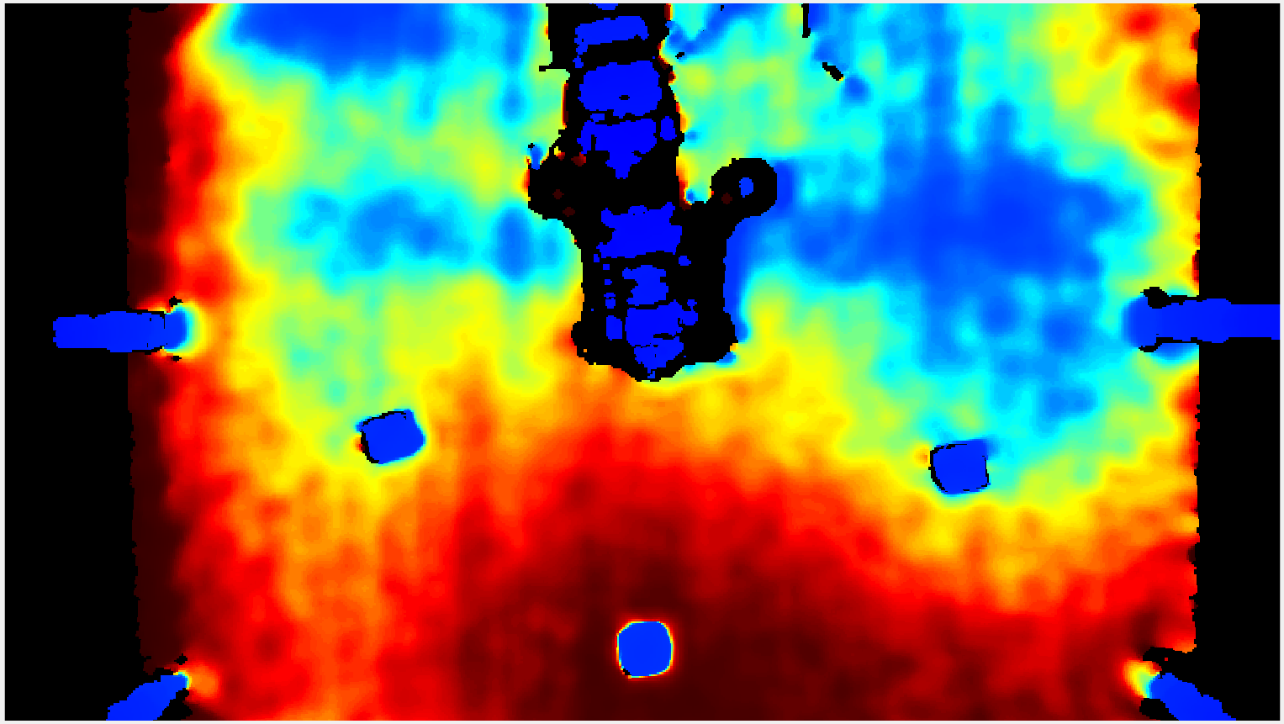

Hence, aligning color plane on depth plane is preferred. Since we prefer downscaling of the images to better work with them.

Task 8.7

